Experiment Number: 1
Simulation and Comparative Analysis of FDMA, TDMA and CDMA:
Resource Allocation, User Capacity and Mobile-Generation Context
Aim
To simulate and compare the basic resource-allocation methods used in FDMA, TDMA and
CDMA, and examine how their assumed user capacity and interference behaviour differ.
Objectives
By the end of the experiment, students should be able to:
1. Model how FDMA, TDMA and CDMA allocate communication resources among
users.
2. Estimate and compare user capacity under stated assumptions.
3. Plot how estimated CDMA SIR changes as the number of simultaneous users increases.
4. Relate the access methods to representative mobile generations and interpret the limits
of the simplified model.
Requirements
• Computer with MATLAB
• No hardware is required
Theoretical Background
FDMA gives users separate frequency channels. TDMA gives users separate time slots. CDMA
allows users to share a frequency band and time by using different spreading codes.
This experiment uses a simplified analytical model to illustrate those differences. It assumes
ideal FDMA and TDMA resource separation, and estimates CDMA SIR using:
SIR = G / K − 1
where G is the processing gain and K is the number of simultaneous users. SIR in decibels is:
SIR dB = 10 log10 SIR
The model assumes ideal separation for FDMA and TDMA, and equal received power for
CDMA users. It does not model fading, power control, adjacent-channel leakage, guard
intervals or standard-specific constraints.

Parameters
1. Total Bandwidth: 1 MHz – Total available frequency bandwidth.
2. FDMA Channel Width: 200 kHz – Bandwidth allocated to each FDMA user.
3. TDMA Slots: 8 – Number of slots available per frame.
4. CDMA Processing Gain: 64 – Assumed spreading/processing gain.
5. CDMA Target SIR: 7 dB – Minimum assumed Signal-to-Interference Ratio (SIR) for the capacity estimate.
Algorithm
a. Clear the MATLAB workspace, Command Window and open figures.
b. Enter the system parameters.
c. Estimate the FDMA and TDMA user limits.
d. Convert the CDMA target SIR from decibels to a linear value.
e. Estimate the CDMA user limit.
f. Calculate CDMA SIR for a range of simultaneous user counts.
g. Display the capacity table and generate the plots.
h. Compare the results with the assumptions and explain their limitations.
Procedure
1. Run the MATLAB program below.
2. Record the assumed bandwidth, channel width, number of TDMA slots, CDMA
processing gain and target SIR.
3. Inspect the printed capacity table and the capacity and CDMA-SIR plots.
4. Inspect the generation comparison table and the conceptual time-frequency resource
diagrams.
5. Change at least one parameter for each access method and rerun the program.
6. Compare the new and baseline results; explain the impact of the changed assumptions.

Program 1 — Capacity estimate for FDMA, TDMA and CDMA
Objective 1: To estimate and compare the illustrative number of users supported by FDMA, TDMA and CDMA using the specified system parameters.
MATLAB program
>> % Comparison of FDMA, TDMA and CDMA
% Simplified illustrative model; not a full cellular-network simulation.
clear; clc; close all;
% Illustrative system parameters
totalBandwidthHz = 1e6; % Total bandwidth: 1 MHz
fdmaChannelHz = 200e3; % FDMA channel width: 200 kHz
tdmaSlots = 8; % Number of TDMA slots per frame
processingGain = 64; % CDMA processing gain
targetSIRdB = 7; % Minimum acceptable CDMA SIR
% Capacity estimates under the stated assumptions
fdmaUsers = floor(totalBandwidthHz / fdmaChannelHz);
tdmaUsers = tdmaSlots;
targetSIR = 10^(targetSIRdB / 10);
cdmaUsers = floor(1 + processingGain / targetSIR);
fprintf('Illustrative maximum supported users\n');
fprintf('FDMA: %d users\n', fdmaUsers);
fprintf('TDMA: %d users\n', tdmaUsers);
fprintf('CDMA: %d users at a target SIR of %.1f dB\n\n', ...
cdmaUsers, targetSIRdB);
% CDMA SIR as the number of simultaneous users increases
K = 2:30;
sirLinear = processingGain ./ (K - 1);
sirDb = 10 * log10(sirLinear);
% Display a comparison table
method = ["FDMA"; "TDMA"; "CDMA"];
supportedUsers = [fdmaUsers; tdmaUsers; cdmaUsers];

results = table(method, supportedUsers);
disp(results);
% Plot estimated user capacity
figure;
bar(categorical(method), supportedUsers);
ylabel('Illustrative maximum supported simultaneous users');
title('FDMA, TDMA and CDMA: Capacity Estimate');
grid on;
% Plot estimated CDMA SIR as users are added
figure;
plot(K, sirDb, 'o-', 'LineWidth', 1.5);
hold on;
yline(targetSIRdB, '--r', 'Target SIR');
xlabel('Number of simultaneous CDMA users (K)');
ylabel('Estimated SIR (dB)');
title('Estimated CDMA SIR versus Number of Users');
grid on;
hold off;

Result
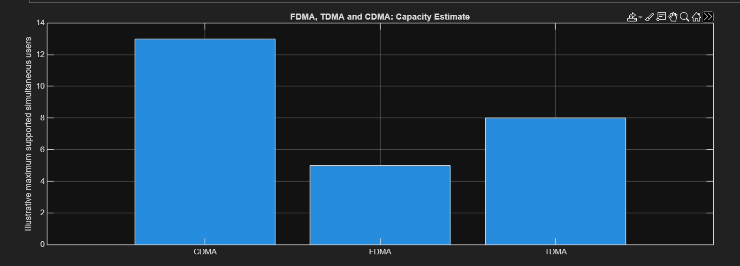

Objective 2: CDMA SIR analysis:
To analyze how the estimated CDMA signal-to-interference ratio changes as the number of
simultaneous user’s increases.
Finding out the SIR for the technique with the highest number of users
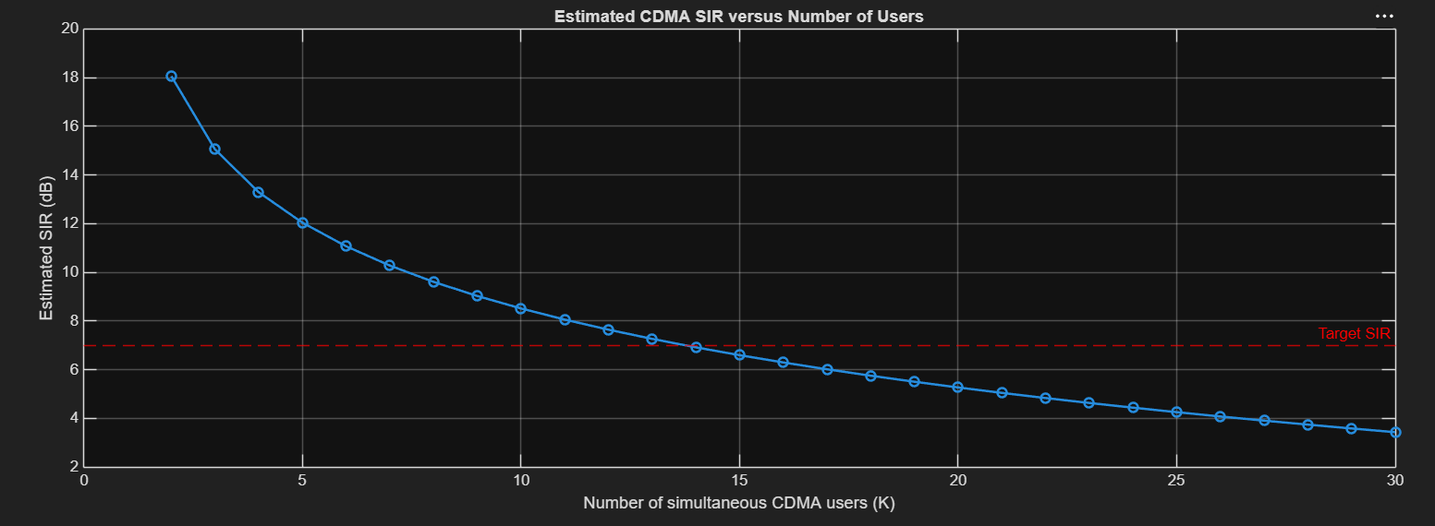
Objective 3: Mobile-generation comparison:
To relate representative multiple-access techniques to the evolution of mobile communication
systems from 1G to 5G.
MATLAB Program:
generation = ["1G"; "2G"; "2G"; "3G"; "4G"; "5G"];
system = ["AMPS"; "GSM"; "IS-95"; "UMTS"; "LTE"; "5G NR"];
accessMethod = ["FDMA"; "TDMA"; "CDMA"; "WCDMA"; "OFDMA"; "OFDMA-based"];
keyIdea = ["Separate frequency channels"; ...
"Separate time slots"; ...
"Code-based user separation"; ...
"Wideband code-based access"; ...
"Orthogonal frequency resources"; ...
"Flexible OFDM-based radio access"];

evolutionTable = table(generation, system, accessMethod, keyIdea);
disp(evolutionTable);
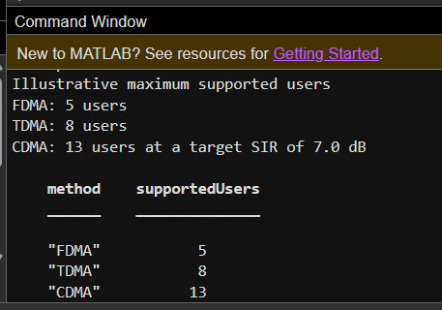
Objective 4: Resource-allocation diagrams:
To visualize how FDMA, TDMA and CDMA assign frequency, time and code resources to
multiple users.
MATLAB Program
Time-frequency resource-allocation diagrams
figure;
tiledlayout(1,3);
% FDMA: users occupy different frequency channels
nexttile;
hold on;
colors = lines(4);
for u = 1:4
rectangle('Position',[0, u-1, 1, 0.8], ...
'FaceColor',colors(u,:), 'EdgeColor','k');
text(0.5, u-0.6, sprintf('User %d',u), ...
'HorizontalAlignment','center');
end
xlim([0 1]); ylim([0 4]);
xlabel('Time');
ylabel('Frequency channel');
title('FDMA');
set(gca,'YTick',[]);
hold off;
% TDMA: users occupy different time slots on one frequency channel
nexttile;
hold on;
for u = 1:4
rectangle('Position',[u-1, 0, 0.8, 1], ...
'FaceColor',colors(u,:), 'EdgeColor','k');
text(u-0.6, 0.5, sprintf('User %d',u), ...
'HorizontalAlignment','center');
end
xlim([0 4]); ylim([0 1]);
xlabel('Time slot');
ylabel('Frequency channel');
title('TDMA');
set(gca,'YTick',[]);
hold off;
% CDMA: users share the same time and frequency band using different codes
nexttile;
hold on;
for u = 1:4
rectangle('Position',[0, 0, 1, 1], ...
'FaceColor',colors(u,:), 'FaceAlpha',0.22, ...
'EdgeColor',colors(u,:), 'LineWidth',1.5);
end
text(0.5, 0.62, 'Users 1-4 share', 'HorizontalAlignment','center');
text(0.5, 0.40, 'band; different codes', 'HorizontalAlignment','center');
xlim([0 1]); ylim([0 1]);
xlabel('Time');
ylabel('Frequency band');
title('CDMA');
set(gca,'YTick',[]);
hold off;
Result
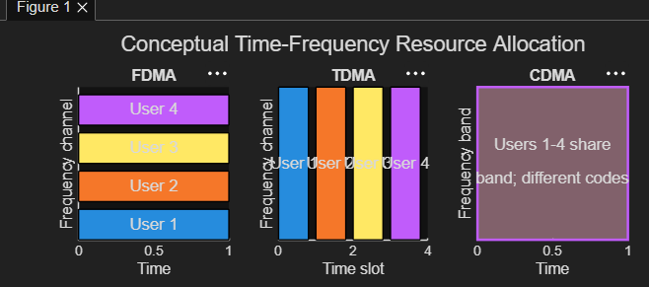
Conclusion
The four MATLAB programs demonstrate how FDMA, TDMA and CDMA allocate communication resources and how the assumed parameters affect their estimated user capacity. The CDMA analysis shows that estimated SIR decreases as more users share the same frequency band. The mobile-generation table and resource-allocation diagrams connect these techniques to the development of wireless communication systems.These results are based on simplified assumptions. In particular, the model assumes ideal FDMA and TDMA separation and does not include real-world effects such as fading, power control, adjacent-channel interference or guard intervals. Therefore, the results illustrate the operating principles; they should not be treated as a universal performance ranking of the three methods.

